25 Things I’ve Learned
by Mike McKinley
May 12, 2008

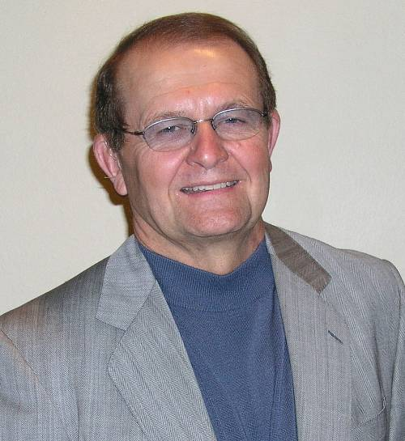
With over 40 years of business experience, Mike McKinley has developed his own unique, hard-hitting, yet humorous motivation speaking style that has educated and entertained audiences throughout the country. At today’s Rotary meeting we, including our 2008 Scholarship Recipients, had the privilege of listening and watching as Mike shared “25 Things He’s Learned”:
Mike McKinley, CSP, CPAE
25. Do for nothing what you would do for money.
24. If you want to be the best, learn from the best.
23. It is wiser to choose what you say than to say what you choose.
22. Mike reviewed some of his successes and failures.
21. Too often you finally get the answer only to find out they’ve already changed the question.
20. Things may come to those who wait, but only the things left by those who hustle.
19. If you’re not making a living, chances are you’re not making much of a difference.
18. Figure out who to affiliate with to get where you want to go.
17. Why be nervous… they don’t know your script!
16. Unless you get up to sing, they’ll never know you have a song.
15. Tell everyone you’re having an excellent time.
14. It’s terrible when your audience is smarter than you are☺
13. Businesses fail because they don’t feel good about who they are, what they do, and who their customers are.
12. Be quicker, better, and different.
11. Plant, then reap. Plant, then reap. Plant, then reap.
10. Customers search for reasons they shouldn’t buy.
9. Prepare for commitment.
8. Expect and thrive on surprise challenges.
7. Figure out what weaknesses need to be addressed immediately.
6. What you want to be remembered for… who you are, what you know, what you say, how you say it, and why you say it.
5. When all else fails, lower your standards☺
4. Relationships gained.
3. Life, labor and love… it’s your choice.
2. Be good at getting better.
1. What is going to be different; I’ll be different; will you?
For more on Mike McKinley, go to: www.realmikemckinley.com

