Program Summary – Argentinean Group Study Exchange Team
April 28, 2008

Meet the Group Student Exchange Team from District 4850, Buenos Aires Argentina:

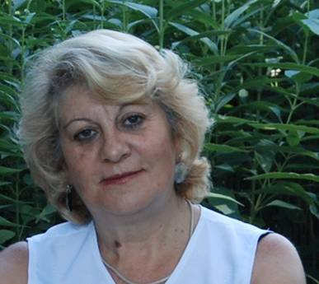
Name:
Graciela Gomez
Psychopedagogic
Assistant
Team
Leader
Uruguay 317
-
General
Viamonte
(6015)
Buenos Aires. Argentina
Home: 54 23580 443135
Mobile: 54 911
-
5957
-
4197
E mail:
gracielaiz@yahoo.com.ar

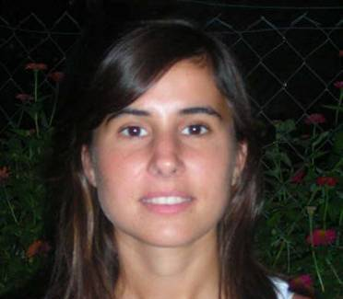

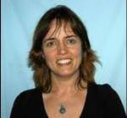

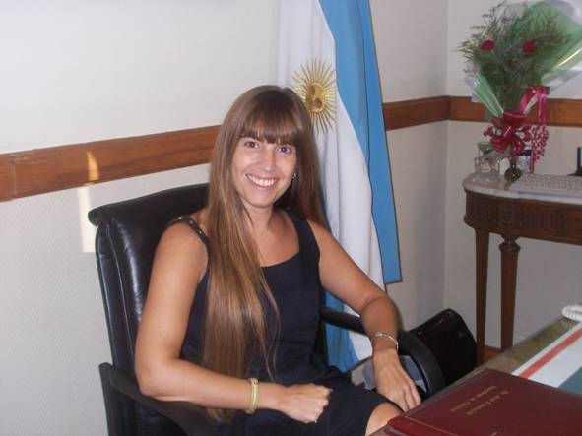

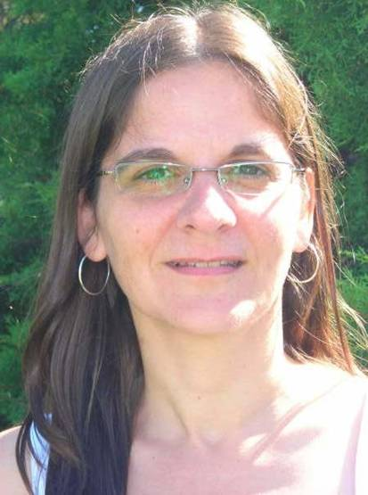
The GSE team arrived in our District 6250 on April 10 and is spending approximately one month visiting Rotary Clubs and attending our District Celebration. Their stay in Wisconsin included a 4-day visit to the Chippewa Valley, during which we had the privilege of meeting the team and listening to their presentation about their country, families and vocations.
All GSE team members work in the human services area… more specifically with people with disabilities. They shared their philosophy by stating that:
“We think children and adults with special needs have to be included in our society. In order for this to happen, the professionals who work with and are near to them have to show society what they are able to do and learn.
“We think society discriminates against people with special needs because they ignore all the very wonderful things they do. A disability is just one aspect… it doesn’t define a person. We are very interested in learning more about this and seeing how the lives and future of special needs people is being improved in other countries.”
and concluded with:
“Person, like birds, are different in their flight, but alike in their right to fly.”
A big thank you goes out to Mark Morse for all of his work in making sure that their stay in the Chippewa Valley was a huge success. See the following article for additional thank-you’s and more information about the team’s activities.

