Adoption
by Beth Opsal
February 25, 2008

A graduate of UW-Eau Claire, Beth Opsal has been an adoption social worker for Lutheran Social Services for the past 11 years.
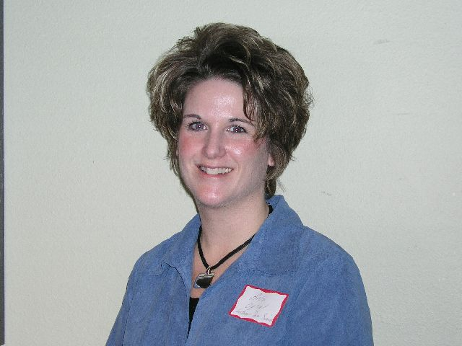
By a show of hands, most of us in the audience have in some way been touched by adoption. It is wonderful avenue to help create loving families. For most, adoption is a two-year process. According to Opsal, there is still a lot of secrecy surrounding adoption. LSS and other agencies are working very hard to make the process more open and to remove the negative stigma that at times is still associated with adoption.
Beth Opsal, Adoption Counselor for Lutheran Social Services
In order to be considered for adoption, a prospective family must go through a rigorous certification process, all for the purpose of determining that the family will provide a safe and stable environment for the child.
There are many different adoption programs offered by many different adoption agencies. At LSS there are separate domestic programs for Caucasian, Minority, and Special Needs children, as well as international programs with various countries throughout the world.
LSS also provides counseling services to those seeking a private adoption and to birth parents about the resources available to them in determining how to best proceed.
Opsal works primarily with International adoptions. The LSS International programs offer adoption opportunities in Mongolia, Guatemala, Philippines and Russia. LSS also collaborates with the Lutheran Adoption Network to offer adoptions from other countries, including Bulgaria, China, Colombia, Moldova, Poland, and Ukraine.
Opsal is very proud of the services provided by all of the adoption agencies in West Central Wisconsin. These groups meet quarterly to share information and to collectively determine ways to be strong advocates for adoption. Along those same lines, adoptive families in this region have formed informal support groups to share their successes and concerns. For more information on LSS, go to www.lssadopt.org.

