Home Country of Indonesia
by our Exchange Student Richard Handoko
May 5, 2008
(Thank you to Robin Shih for providing this “Program Summary”)

Richard Handoko, 18, arrived last summer as our inbound exchange student to spend a year living in Eau Claire. He is a senior at Regis High School and will graduate at the end of May. He has applied to colleges in Singapore, the University of South Dakota, and our very own UWEC.
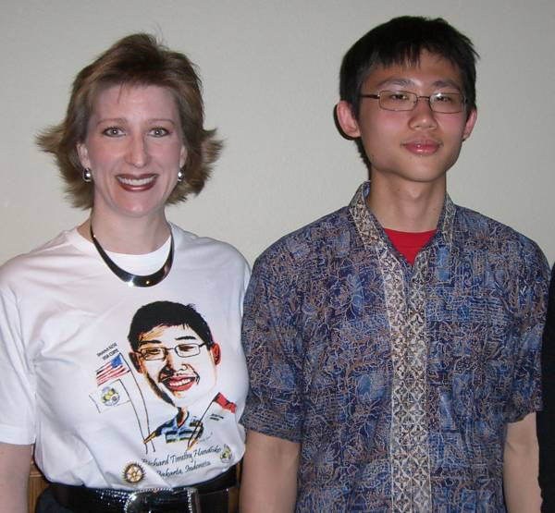
Richard shared information with us about himself, Indonesia, and his home town of Jakarta. He displayed photos of his home, his neighborhood, and his family in Jakarta, which is the capital city on the island of Java. He shares a room with his 15 year old brother and they enjoy playing ping pong when they're not studying. At home, he attended a private Christian school in the hills during the week, living in a dormitory on campus, and returned home on weekends. Indonesia is a tropical country and the weather is always warm. He and his classmates enjoy a swimming pool at their school. It was a tough adjustment getting used to the colder weather in Wisconsin.
The Republic of Indonesia's flag is red and white: red = bravery and white = virtue. It is a democratic republic that celebrates its independence on the 17th of August (1945). The currency is Rupiah. One U.S. dollar equals 9,000 Rupiah, thus life for Richard in the US is very expensive. Indonesia is a series of islands in Southeast Asia located between Australia and Asia. There are more than 17,500 islands of which 6,000 are inhabited and 1,000 are permanently settled. The five major islands of Indonesia are Java, Sumatra, Borneo, Sulawesi, and Papua. There are 400 volcanoes in Indonesia, 100 of which are still active. 87% of the population is Muslim, 6% Christian, 3% Catholic, and 2% Hindu, Buddhist, or other. The ethnic groups are mainly Malay and Melanesian. There are 500 ethnic groups and 731 languages. The national language is Indonesian. Wood furniture is among the many exports of the country including coffee, palm oil, and Batik (a clothing technique made from wax and soaking cloth in color dyes). Richard modeled his Batik shirt for his presentation. Richard's parents own a furniture company in Jakarta.
Pictured: Robin Shih Youth Exchange Counselor and Richard Handoko, Exchange Student from Jakarta, Indonesia. Robin is wearing a likeness tee shirt designed by Richard, while Richard is wearing a traditional Indonesian Batik shirt.
Not pictured: Sherry Mohr, Youth Exchange Officer.
Jakarta is flat, hot, humid, and very crowded. 14 million people live in 255 square miles. At the end of the presentation, Richard shared photos of his home, his family, his relatives and friends, the national palace (which is also white like our own White House), the national monument, the history museum, and the many cars and vendors which make up a big part of the culture in his hometown.
We are grateful to have Richard with us this year to share his experiences and culture with all of us. He is a brilliant, talented, and delightful young man we are grateful to know.

